Creating a project:

1. >ng new SimpleAngularApp
2. Accept the Defaults

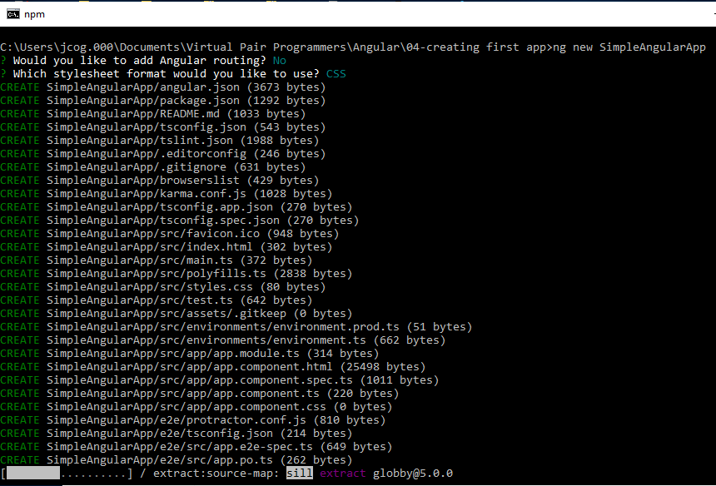

Created a new project:

>ng new DemoApp

C:\Users\jcog.000\Documents\Virtual Pair Programmers\Angular\workspace>ng new DemoApp

? Would you like to add Angular routing? No

? Which stylesheet format would you like to use? CSS

CREATE DemoApp/angular.json (3601 bytes)

CREATE DemoApp/package.json (1282 bytes)

CREATE DemoApp/README.md (1024 bytes)

CREATE DemoApp/tsconfig.json (543 bytes)

CREATE DemoApp/tslint.json (1988 bytes)

CREATE DemoApp/.editorconfig (246 bytes)

CREATE DemoApp/.gitignore (631 bytes)

CREATE DemoApp/browserslist (429 bytes)

CREATE DemoApp/karma.conf.js (1019 bytes)

CREATE DemoApp/tsconfig.app.json (270 bytes)

CREATE DemoApp/tsconfig.spec.json (270 bytes)

CREATE DemoApp/src/favicon.ico (948 bytes)

CREATE DemoApp/src/index.html (293 bytes)

CREATE DemoApp/src/main.ts (372 bytes)

CREATE DemoApp/src/polyfills.ts (2838 bytes)

CREATE DemoApp/src/styles.css (80 bytes)

CREATE DemoApp/src/test.ts (642 bytes)

CREATE DemoApp/src/assets/.gitkeep (0 bytes)

CREATE DemoApp/src/environments/environment.prod.ts (51 bytes)

CREATE DemoApp/src/environments/environment.ts (662 bytes)

CREATE DemoApp/src/app/app.module.ts (314 bytes)

CREATE DemoApp/src/app/app.component.html (25498 bytes)

CREATE DemoApp/src/app/app.component.spec.ts (984 bytes)

CREATE DemoApp/src/app/app.component.ts (211 bytes)

CREATE DemoApp/src/app/app.component.css (0 bytes)

CREATE DemoApp/e2e/protractor.conf.js (810 bytes)

CREATE DemoApp/e2e/tsconfig.json (214 bytes)

CREATE DemoApp/e2e/src/app.e2e-spec.ts (640 bytes)

CREATE DemoApp/e2e/src/app.po.ts (262 bytes)

> core-js@2.6.9 postinstall C:\Users\jcog.000\Documents\Virtual Pair Programmers\Angular\workspace\DemoApp\node_modules\babel-runtime\node_modules\core-js

> node scripts/postinstall || echo "ignore"

> core-js@3.2.1 postinstall C:\Users\jcog.000\Documents\Virtual Pair Programmers\Angular\workspace\DemoApp\node_modules\core-js

> node scripts/postinstall || echo "ignore"

> core-js@2.6.9 postinstall C:\Users\jcog.000\Documents\Virtual Pair Programmers\Angular\workspace\DemoApp\node_modules\karma\node_modules\core-js

> node scripts/postinstall || echo "ignore"

> @angular/cli@8.3.4 postinstall C:\Users\jcog.000\Documents\Virtual Pair Programmers\Angular\workspace\DemoApp\node_modules\@angular\cli

> node ./bin/postinstall/script.js

npm WARN optional SKIPPING OPTIONAL DEPENDENCY: fsevents@1.2.9 (node_modules\webpack-dev-server\node_modules\fsevents):

npm WARN notsup SKIPPING OPTIONAL DEPENDENCY: Unsupported platform for fsevents@1.2.9: wanted {"os":"darwin","arch":"any"} (current: {"os":"win32","arch":"x64"})

npm WARN optional SKIPPING OPTIONAL DEPENDENCY: fsevents@1.2.9 (node_modules\watchpack\node_modules\fsevents):

npm WARN notsup SKIPPING OPTIONAL DEPENDENCY: Unsupported platform for fsevents@1.2.9: wanted {"os":"darwin","arch":"any"} (current: {"os":"win32","arch":"x64"})

npm WARN optional SKIPPING OPTIONAL DEPENDENCY: fsevents@1.2.9 (node_modules\karma\node_modules\fsevents):

npm WARN notsup SKIPPING OPTIONAL DEPENDENCY: Unsupported platform for fsevents@1.2.9: wanted {"os":"darwin","arch":"any"} (current: {"os":"win32","arch":"x64"})

npm WARN optional SKIPPING OPTIONAL DEPENDENCY: fsevents@1.2.9 (node_modules\@angular\compiler-cli\node_modules\fsevents):

npm WARN notsup SKIPPING OPTIONAL DEPENDENCY: Unsupported platform for fsevents@1.2.9: wanted {"os":"darwin","arch":"any"} (current: {"os":"win32","arch":"x64"})

npm WARN optional SKIPPING OPTIONAL DEPENDENCY: fsevents@2.0.7 (node_modules\fsevents):

npm WARN notsup SKIPPING OPTIONAL DEPENDENCY: Unsupported platform for fsevents@2.0.7: wanted {"os":"darwin","arch":"any"} (current: {"os":"win32","arch":"x64"})

added 1186 packages from 1051 contributors and audited 18840 packages in 679.338s

found 0 vulnerabilities

warning: LF will be replaced by CRLF in .editorconfig.

The file will have its original line endings in your working directory.

warning: LF will be replaced by CRLF in .gitignore.

The file will have its original line endings in your working directory.

warning: LF will be replaced by CRLF in README.md.

The file will have its original line endings in your working directory.

warning: LF will be replaced by CRLF in angular.json.

The file will have its original line endings in your working directory.

warning: LF will be replaced by CRLF in browserslist.

The file will have its original line endings in your working directory.

warning: LF will be replaced by CRLF in e2e/protractor.conf.js.

The file will have its original line endings in your working directory.

warning: LF will be replaced by CRLF in e2e/src/app.e2e-spec.ts.

The file will have its original line endings in your working directory.

warning: LF will be replaced by CRLF in e2e/src/app.po.ts.

The file will have its original line endings in your working directory.

warning: LF will be replaced by CRLF in e2e/tsconfig.json.

The file will have its original line endings in your working directory.

warning: LF will be replaced by CRLF in karma.conf.js.

The file will have its original line endings in your working directory.

warning: LF will be replaced by CRLF in package-lock.json.

The file will have its original line endings in your working directory.

warning: LF will be replaced by CRLF in package.json.

The file will have its original line endings in your working directory.

warning: LF will be replaced by CRLF in src/app/app.component.html.

The file will have its original line endings in your working directory.

warning: LF will be replaced by CRLF in src/app/app.component.spec.ts.

The file will have its original line endings in your working directory.

warning: LF will be replaced by CRLF in src/app/app.component.ts.

The file will have its original line endings in your working directory.

warning: LF will be replaced by CRLF in src/app/app.module.ts.

The file will have its original line endings in your working directory.

warning: LF will be replaced by CRLF in src/environments/environment.prod.ts.

The file will have its original line endings in your working directory.

warning: LF will be replaced by CRLF in src/environments/environment.ts.

The file will have its original line endings in your working directory.

warning: LF will be replaced by CRLF in src/index.html.

The file will have its original line endings in your working directory.

warning: LF will be replaced by CRLF in src/main.ts.

The file will have its original line endings in your working directory.

warning: LF will be replaced by CRLF in src/polyfills.ts.

The file will have its original line endings in your working directory.

warning: LF will be replaced by CRLF in src/styles.css.

The file will have its original line endings in your working directory.

warning: LF will be replaced by CRLF in src/test.ts.

The file will have its original line endings in your working directory.

warning: LF will be replaced by CRLF in tsconfig.app.json.

The file will have its original line endings in your working directory.

warning: LF will be replaced by CRLF in tsconfig.json.

The file will have its original line endings in your working directory.

warning: LF will be replaced by CRLF in tsconfig.spec.json.

The file will have its original line endings in your working directory.

warning: LF will be replaced by CRLF in tslint.json.

The file will have its original line endings in your working directory.

Successfully initialized git.

C:\Users\jcog.000\Documents\Virtual Pair Programmers\Angular\workspace>

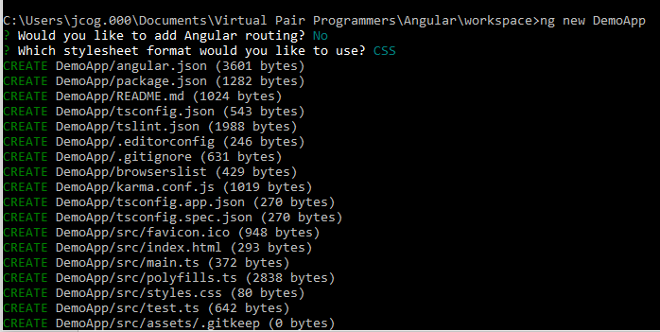

**DemoApp completed!!**

**Now we are ready to add Components!!**

**Create component Page1**

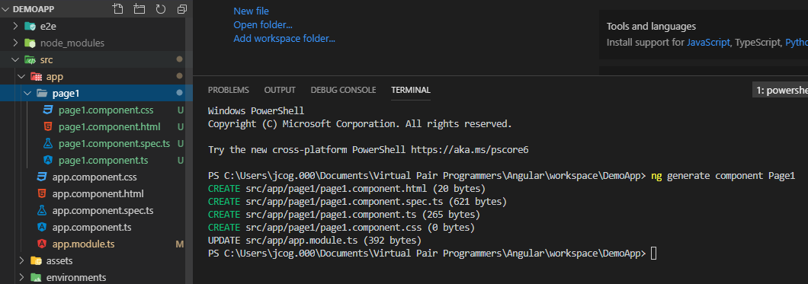

**Where to find all the elements in a project?**

**app.module.ts**

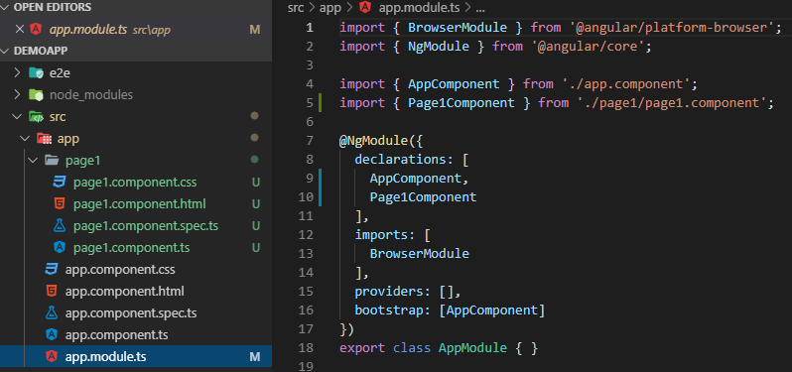

**You can see the page1 is registered here as an import statement**

**and as a declaration**

**Now let us populate the HTML for the Page1 display:**

**Go to the provided files:**

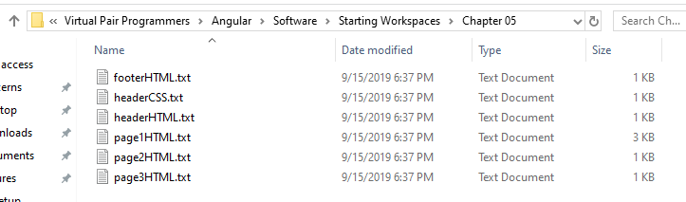

**Copy the page1HTML.txt contents to paste into page1.component.html file:**

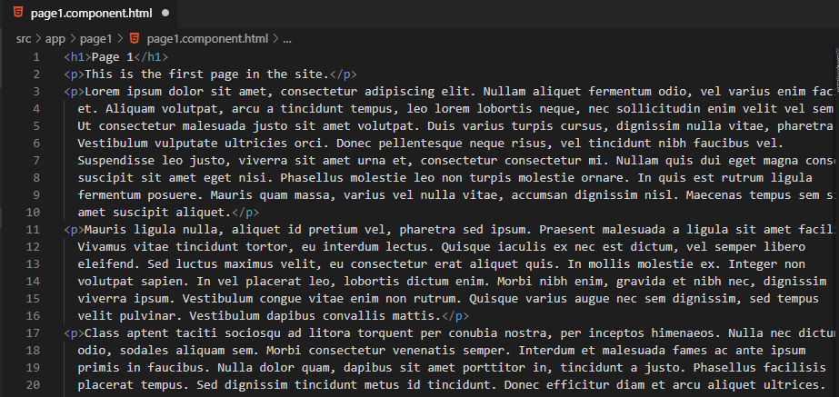

**Replace what is in the app.component.html page with the following:**

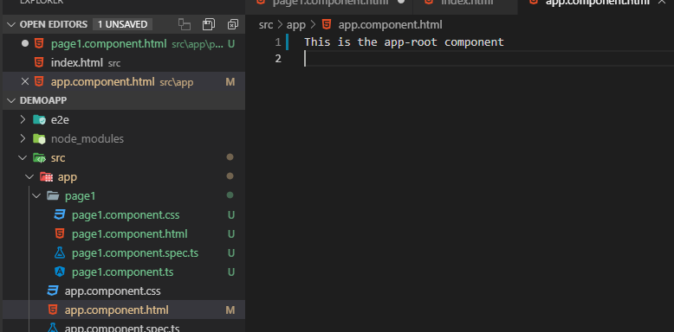

**Now, register the page1 component with the app component.**

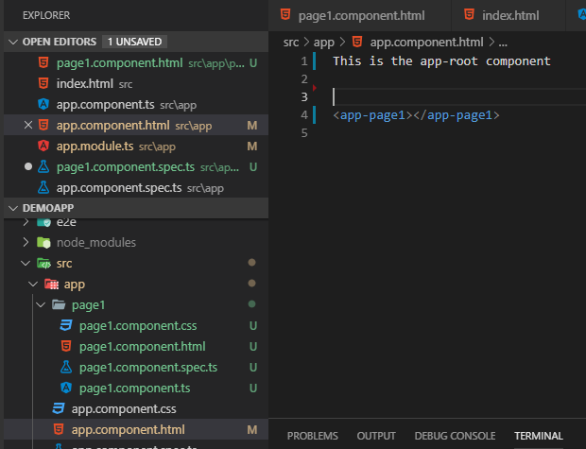

**Refresh happen automatically and the DemoApp now reflects the changes:**

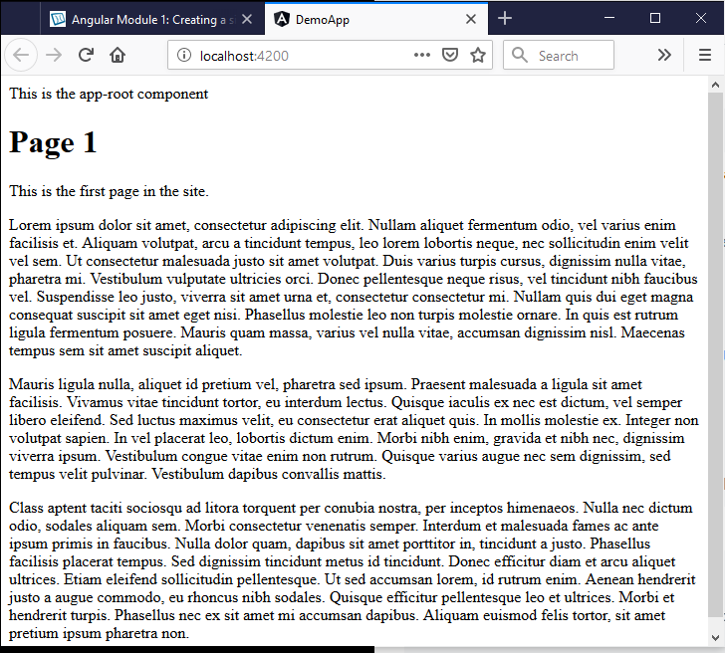

**Build**

**Header contains Header Page1(link) Page2(link) Page3(link) Footer**

**Page2**

**Page3**

**Footer**

**3 stages**

**1 Generate the component**

**2 copy the text to the HTML page**

**3 register the component with a selector in the app.module**

**Template Expressions:**

**TypeScript Class**

Export == public in java

OnInit == interface in java

Empty constructors are the same as the java default constructor

ngOnInit() runs last it is a method found in OnInit interface

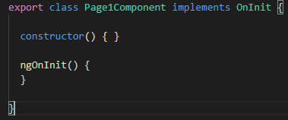

**A variable in the backing class:**

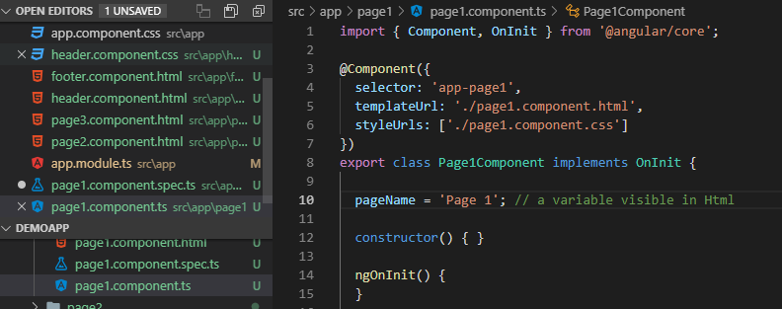

**Now use the {{}} notation in the HTML page to insert the**

**Variable**

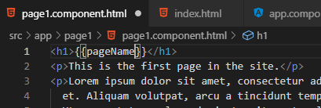

**Check the browser and you see the resulting string variable show the value on the HTML page.**

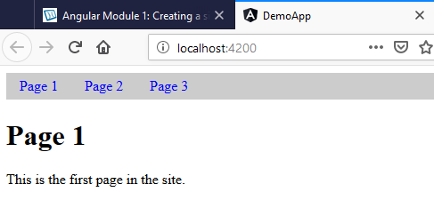

**Let us make it dynamic:**

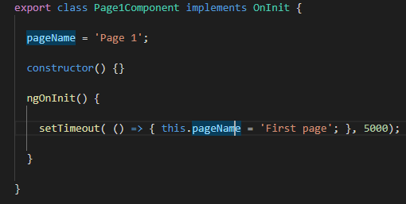

**After 5 seconds the “Page 1” changes to “First page”**

**Make sure you have a space between the {{}}**

**e.g. {{ pageName }}**

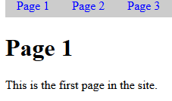

**5 seconds later:**

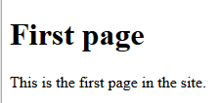

**Event Binding**

**Invoke a method from the Html file:**

1. **A javascript demo**

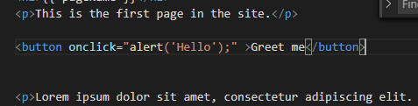

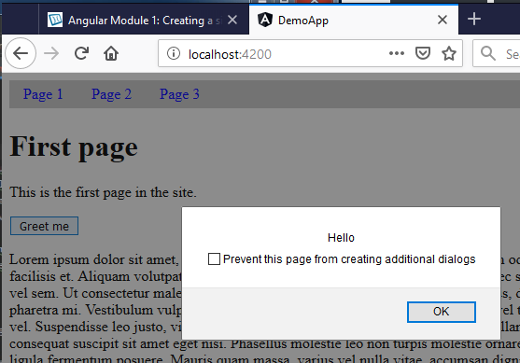

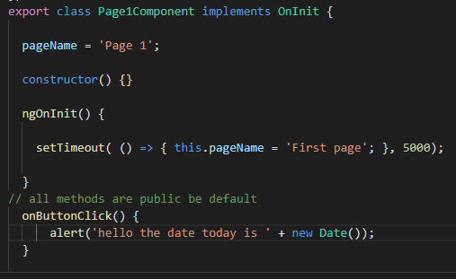

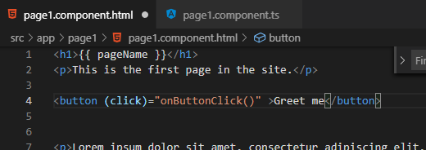

**Now try it!**

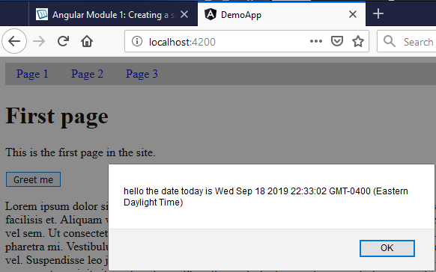

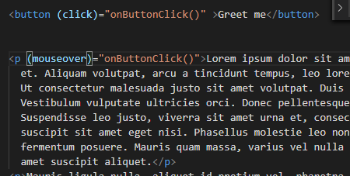

**Mouse over text:**



**Testing with the console:**

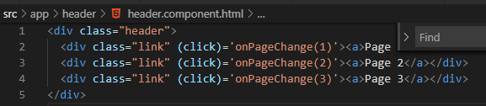

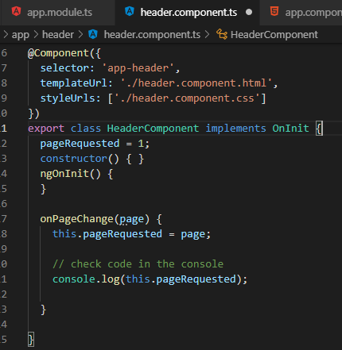

**Click on the links: outputs 1 2 3**

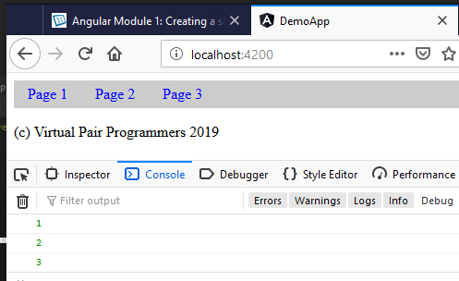

1. **Bind the expression**

**Use [] brackets to [hidden]**

1. **Use !==**

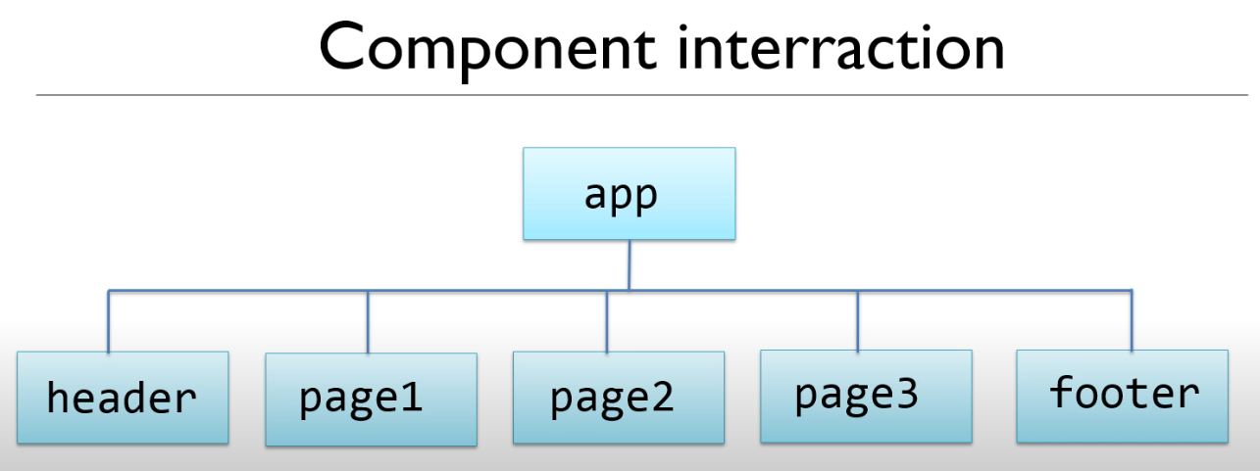

**HeaderComponent.pageRequested**

**You also need app to find it**

**Use a Template Hash Expression**

**<app-header #headerComponent>**

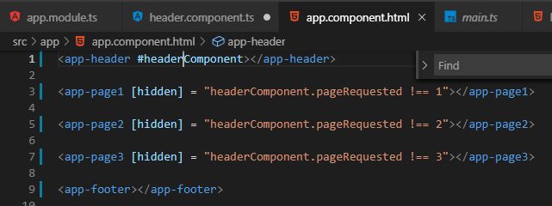

**The links now work**

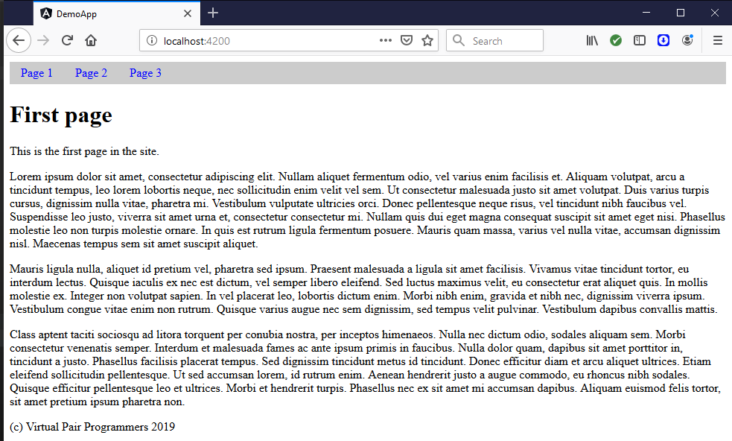

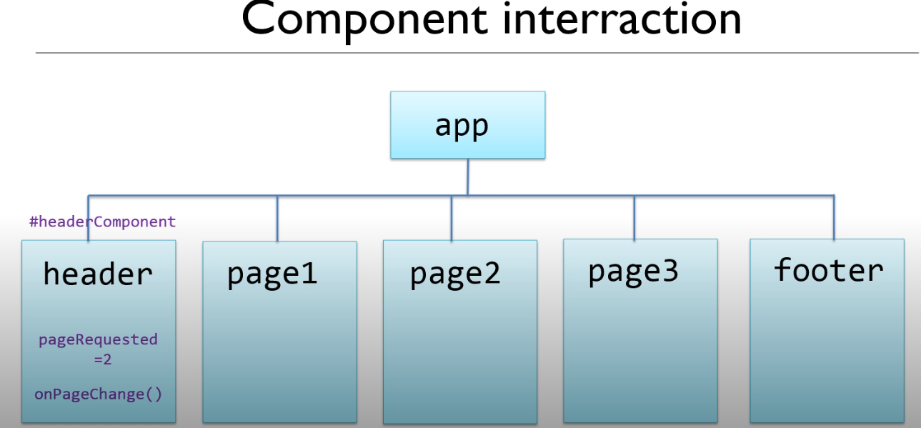

**Include hidden if expression is true**

**Do not include hidden if the expression is false**

**Try using *ng-if is a structural change and not a binding expression!!**

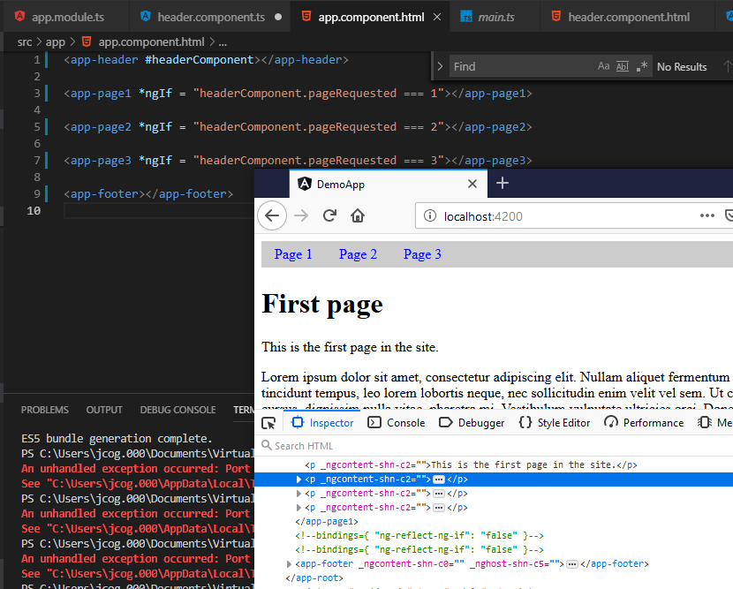

**We have completed the static website DemoApp!!**